**Simulation of Telomere hyper-clusters in yeast**

**Background**: Hyper-clusters of telomere in the yeast cells are formed in a wild-type under normal conditions. However, the exact mechanical mechanism causing clustering and the clusters role is yet to be elucidated. The yeasts’ chromosomes, encored to the nucleus membrane allow the motion of the two arms of the chromosomes, where its telomeres can associate and dissociate. When the telomeres of the yeast chromosome aggregate, a hyper cluster of telomeres is formed.

**Aim**: In this work we aim to show that the formation of the hyper clusters can be explained by the spontaneous motion of the chromosomes’ arms in yeast nucleus, governed by simple rules of association and dissociation of the telomeres.

**Methods**: Using the polymer dynamics simulation framework we have previously constructed, we will simulate the motion of chromosomes arms inside a spherical nucleus domain. All chromosomes will be encored on the nuclear surface (Figure 1 A &B ) and the chromosome arms will be modeled as Rouse chains. Telomeres of different chromosomes are allowed to associate with an association constant *ka* and dissociate constant *kd at* a distance *d*, to form clusters (Figure 1 B) . Association of telomeres will be allowed in a predefined region at the end of the chromosome (Figure 1 C). The statistical properties of hyper clusters will be studied to reveal the probability to form clusters of telomeres of variables sizes and the encounter probability between different parts of the chromosome arms while clustered.

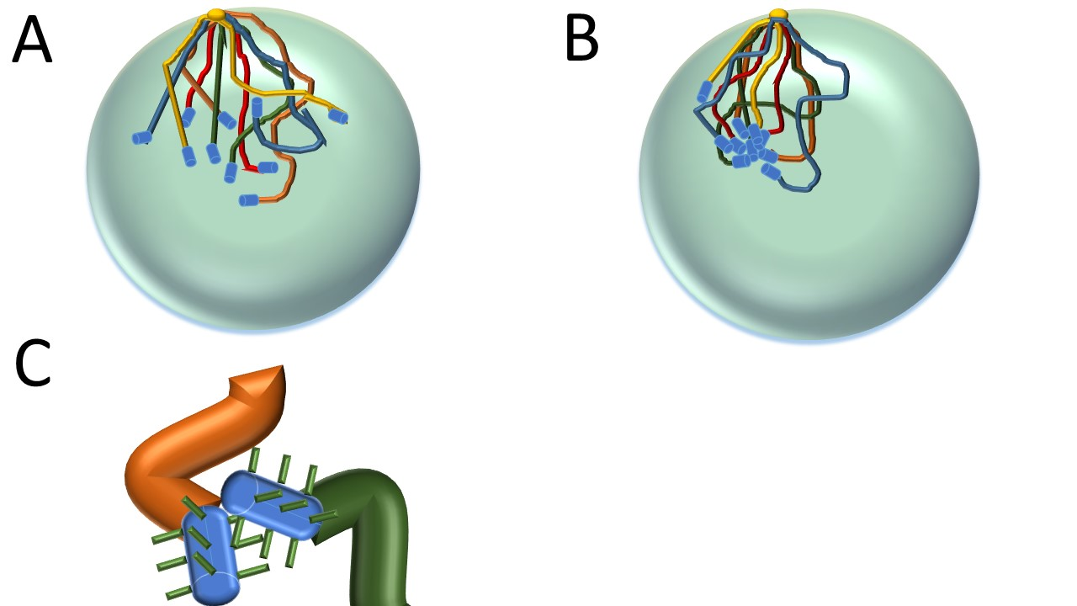

Figure . Simulation of hyper-cluster formation of yeasts' telomeres will be performed in a spherical domain, all chromosomes will be encored at one point (box A, yellow sphere) and their arms will undergo stochastic motion in accordance with the Rouse chain dynamics. A cluster of telomeres is formed when the telomeres associate with one another at an association distance d (box B). Only the ends of the chromosomes are allowed to associate (box C), each with a predefined association region size.